TechConnect

Locaberte, Leynard A.

Miranda, Abegail C.

Endozo, Jasmine S.

Prototype

TulongBatangueño: An Online Management and Recommender System for Urgent Calamity Response in Batangas

**Desktop View**

As the system is not activated it still available but the function for the intended user is no accessible. For the regular user it will present as information system.

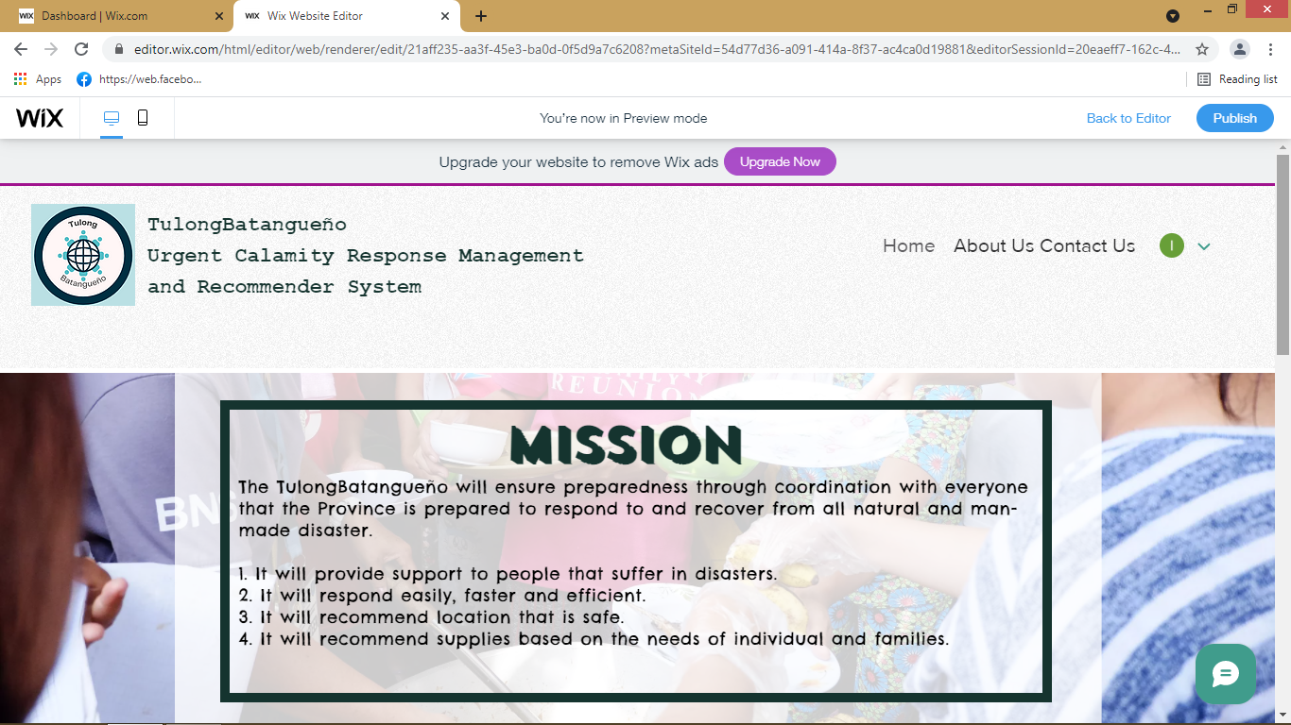

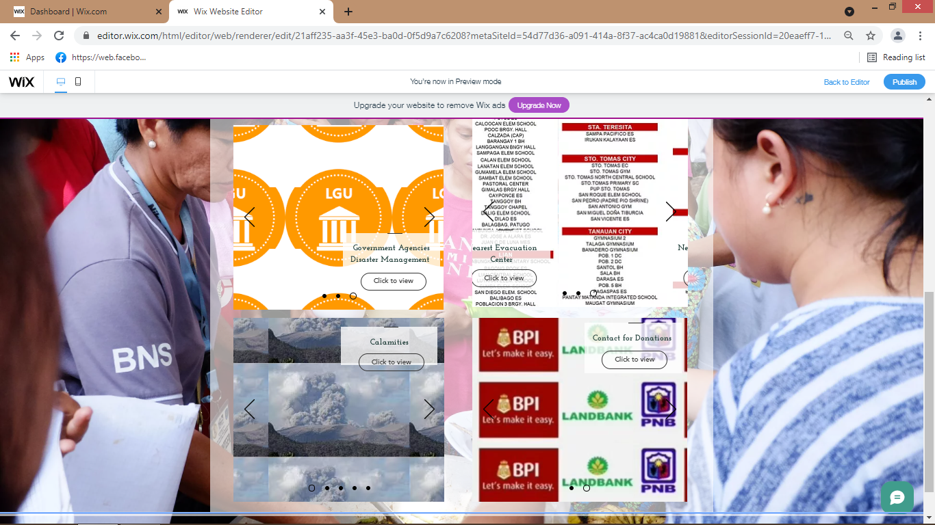

The main page of the system compose of four different modules that give the use in formation like Government institutes, Nearest Evacuation Centre, Calamities Does and Don’ts and for people who wants to donate, the System has Donation.

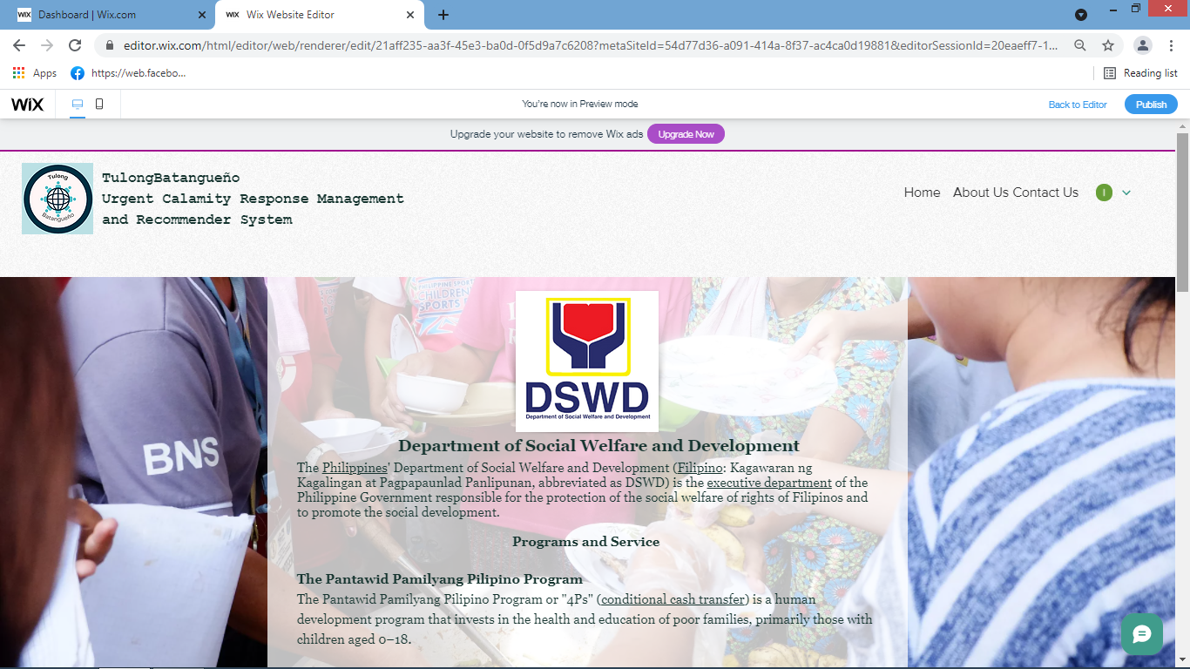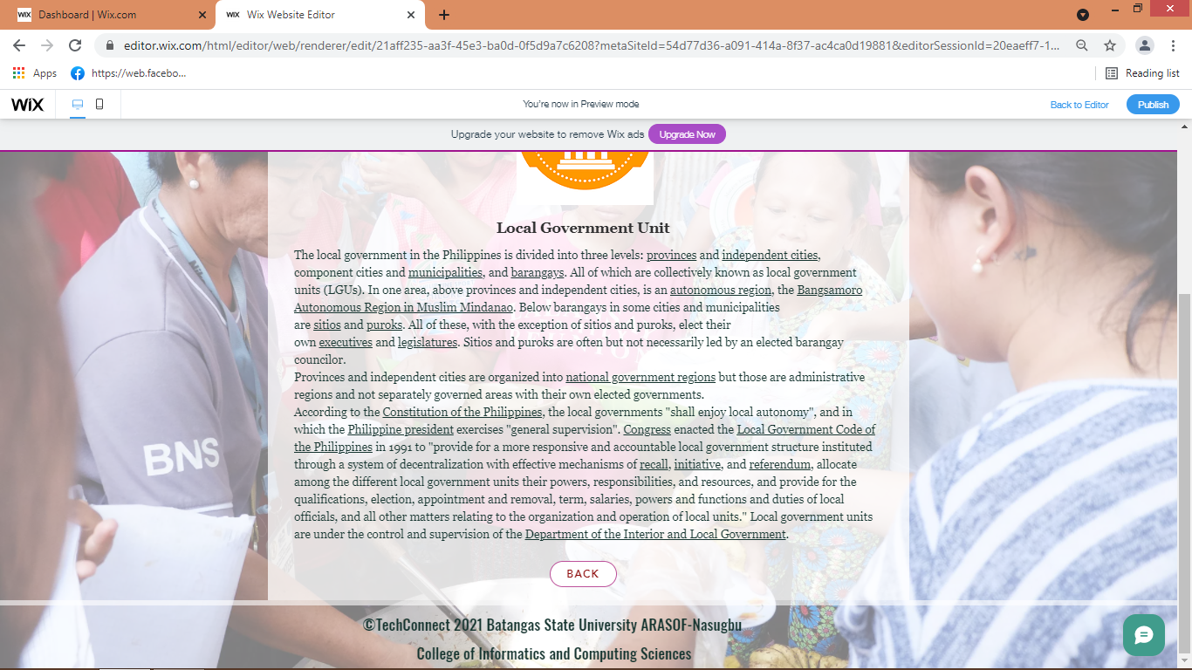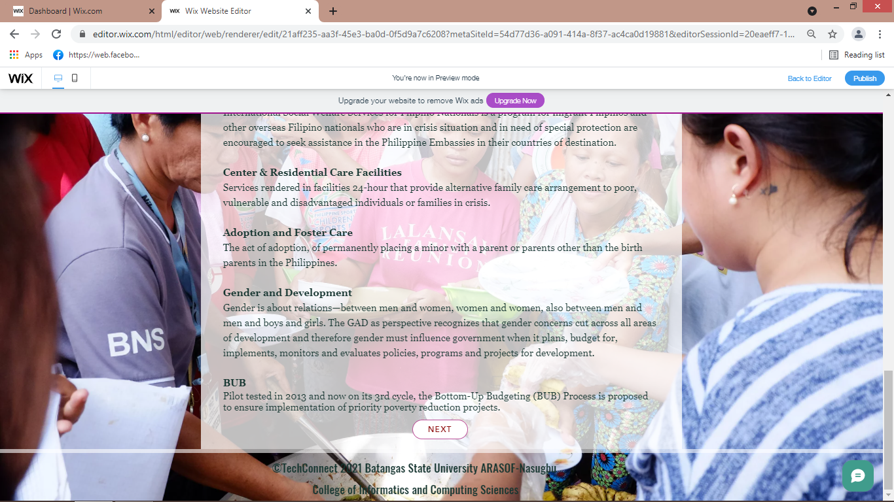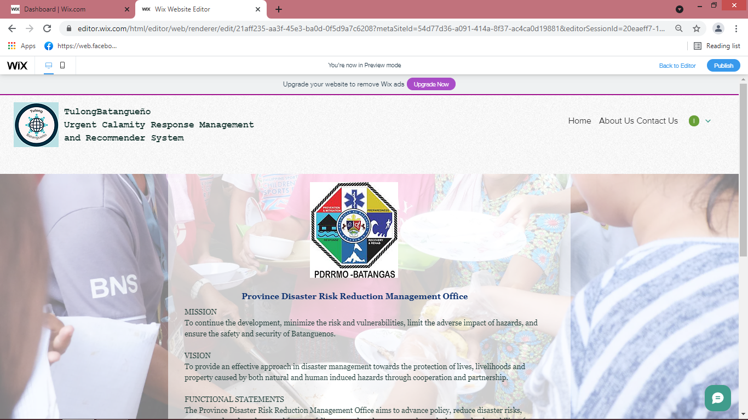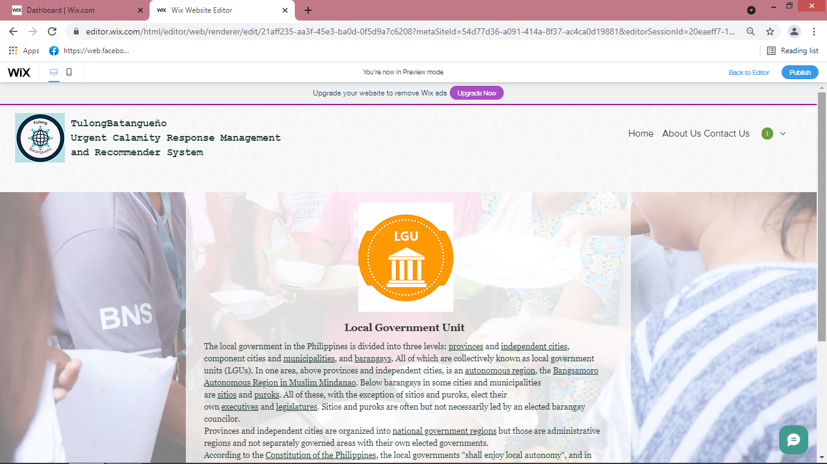

If the user click the Government Agencies,

The information of such agencies will be display and a next button will be provided to navigate the other content.

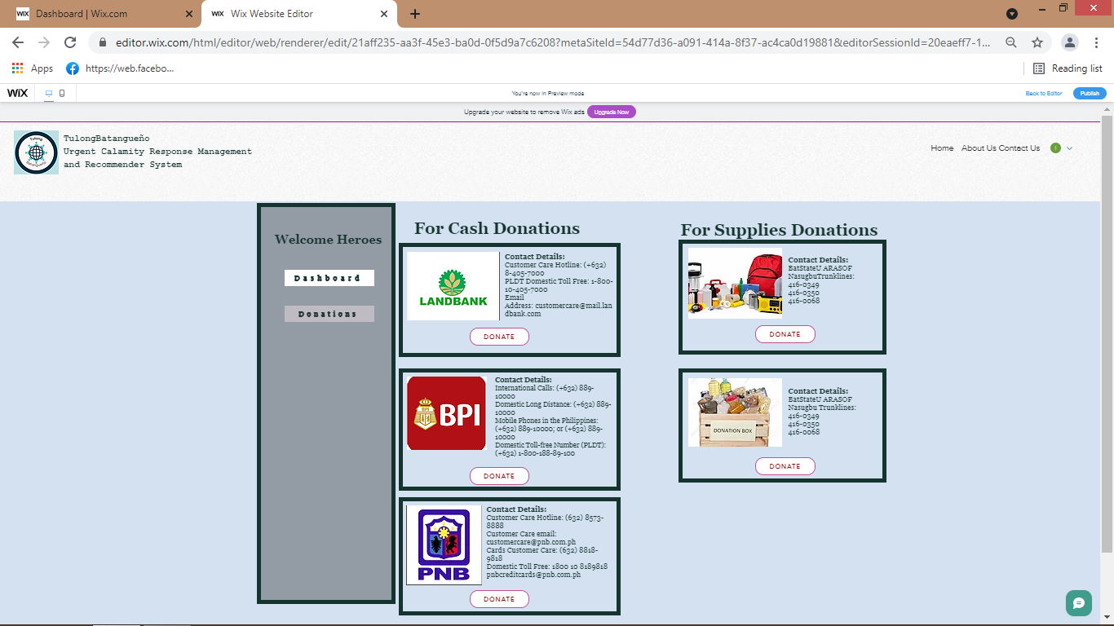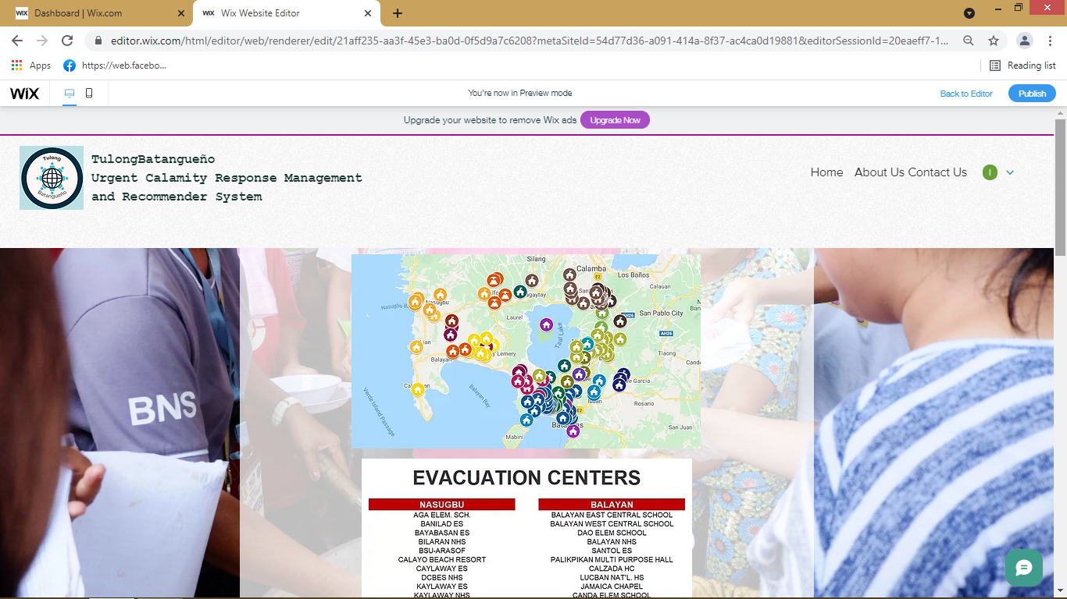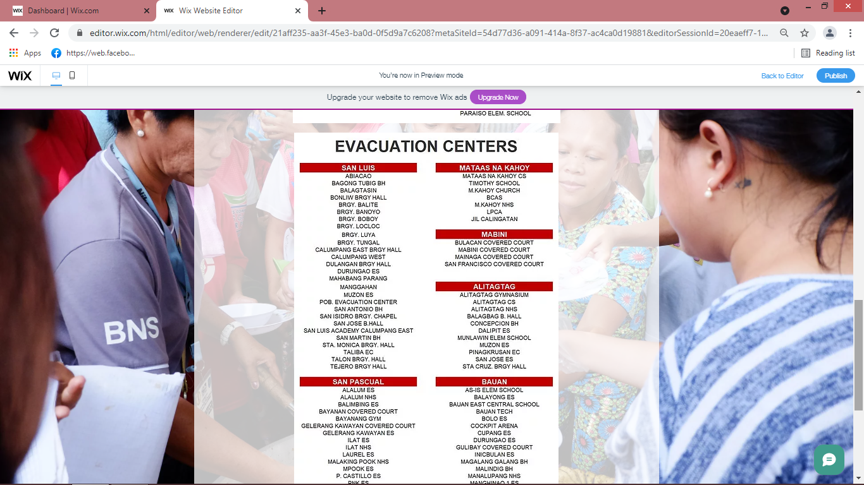

If the users click the Donations, he or she will be forwarded to this page where he or she can donate online via bank partners or contact specific person to donate essential and nonessential goods.

(Screenshot zoom)

If the user click Evacuation Center, the user will be forwarded to this page where display all evacuation in Batangas area. It also has the list of evacuation per barangay.

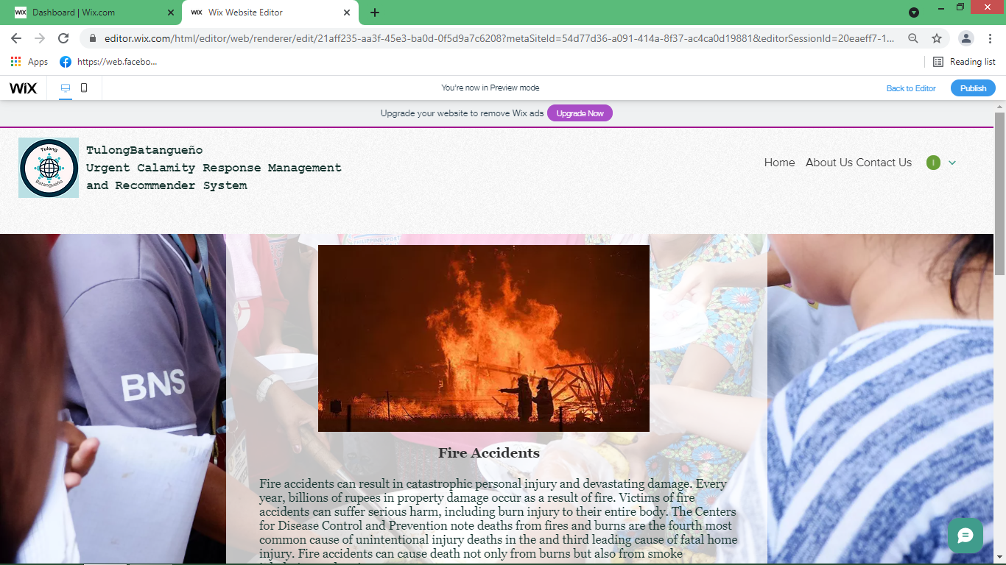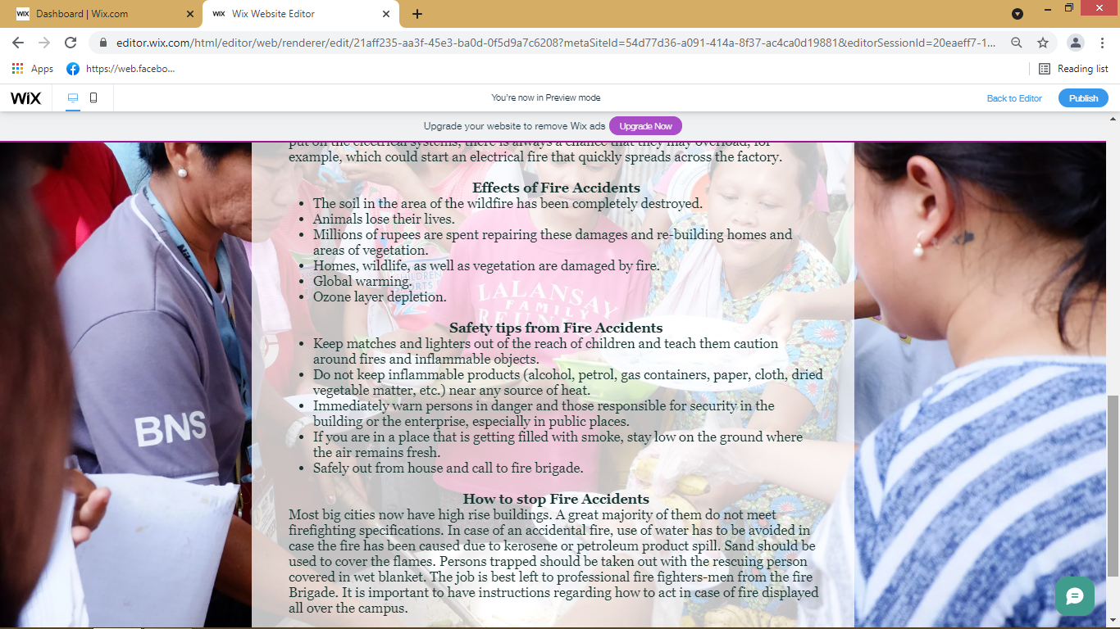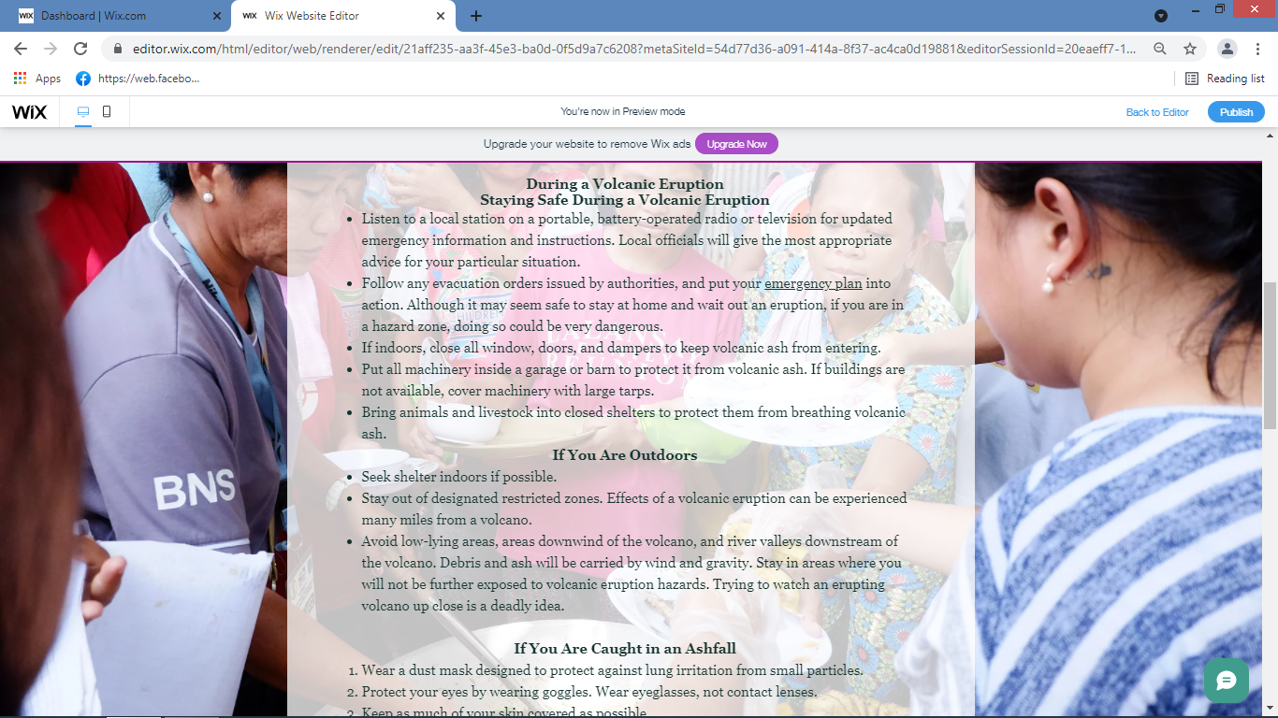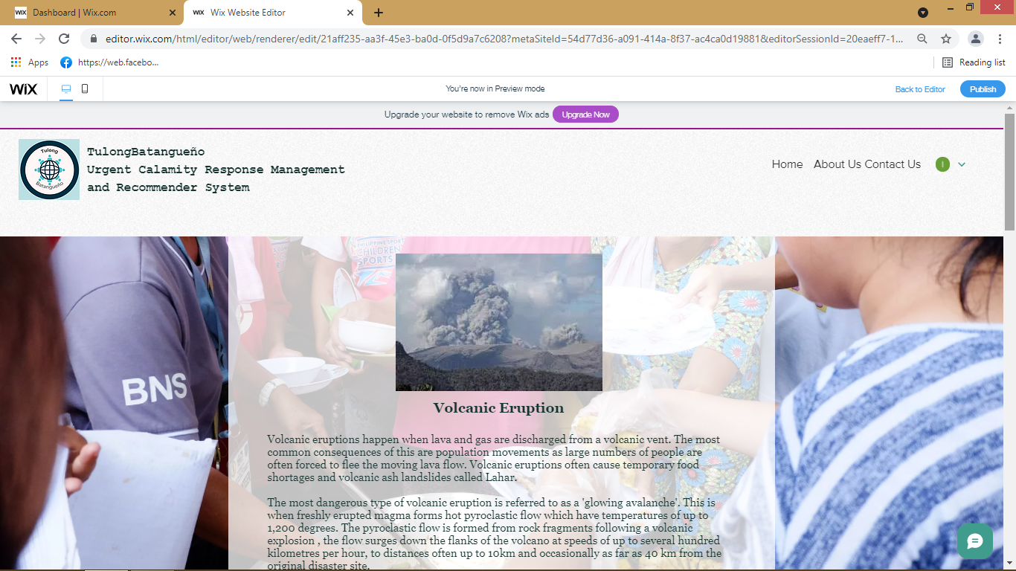

If the users click the Calamities Does and Don’ts, he or she will forwarded to this pages containing information of calamities and things to be done upon the situation.

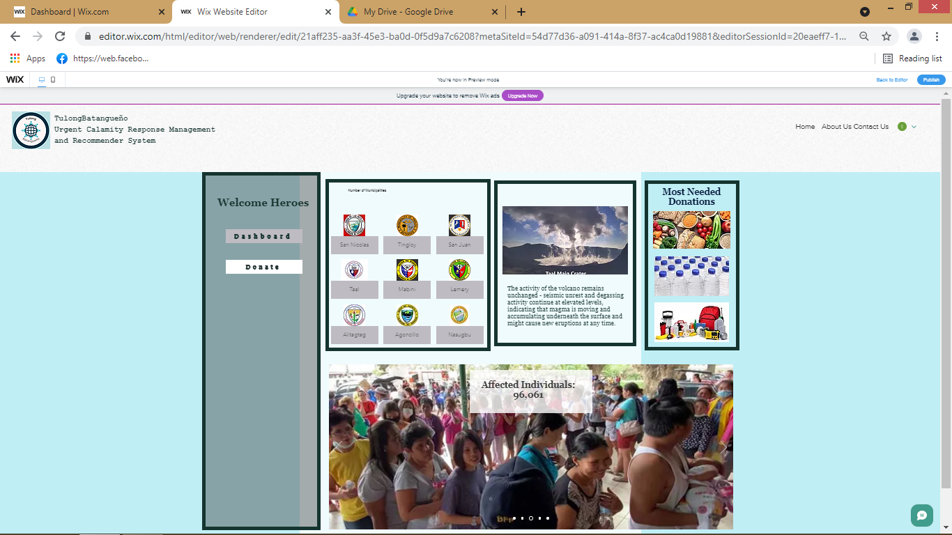

If the user click the Donations, And there is a calamity, he or she will be forwarded to this page where he or she can donate online via bank partners or contact specific person to donate essential and nonessential goods.

(Screenshot zoom)

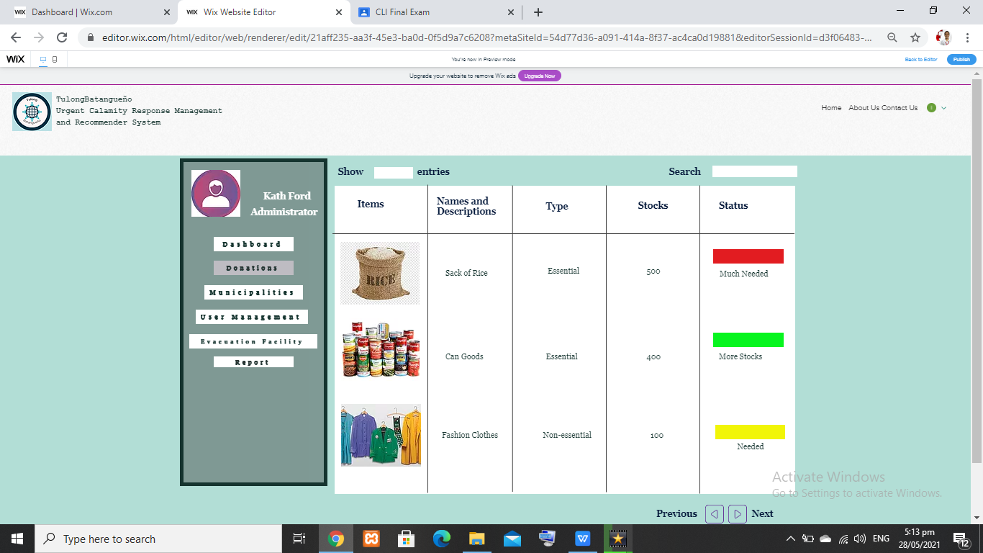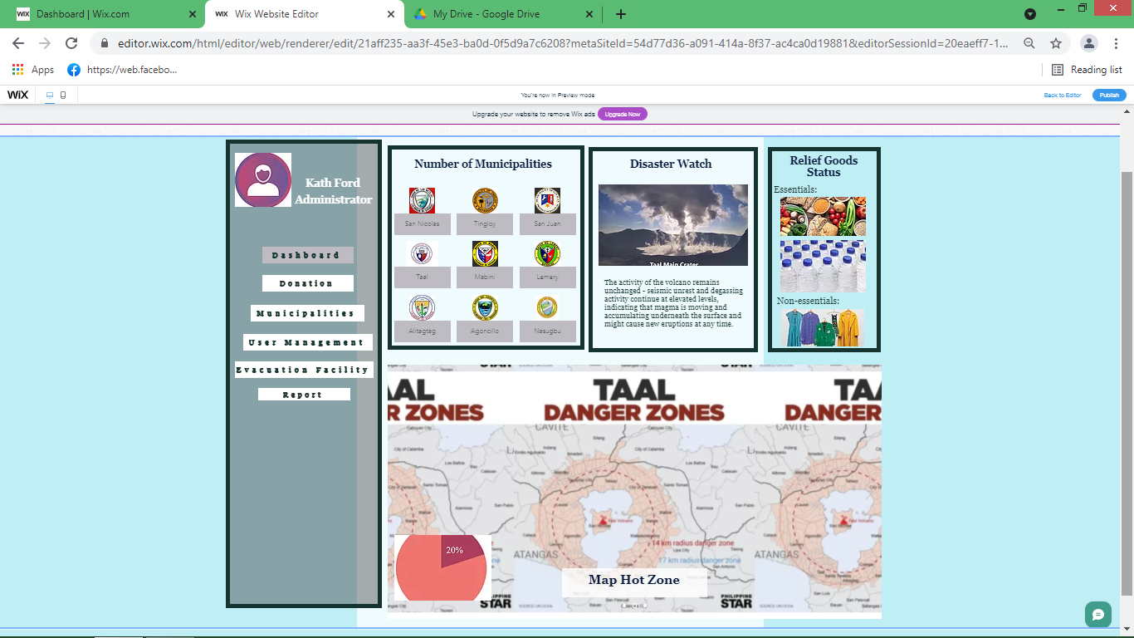

The Donation tab consists the list of items and it’s stock. Also, there is a status represent the how much needed the item. Base on the inventory during a calamity

(Screenshot zoom)

The admin interface is always active as he or she has the authority to activate the accounts of other user in case of Calamity.

This is the dashboard of the admin

(Screenshot zoom)

**Admin Interface**

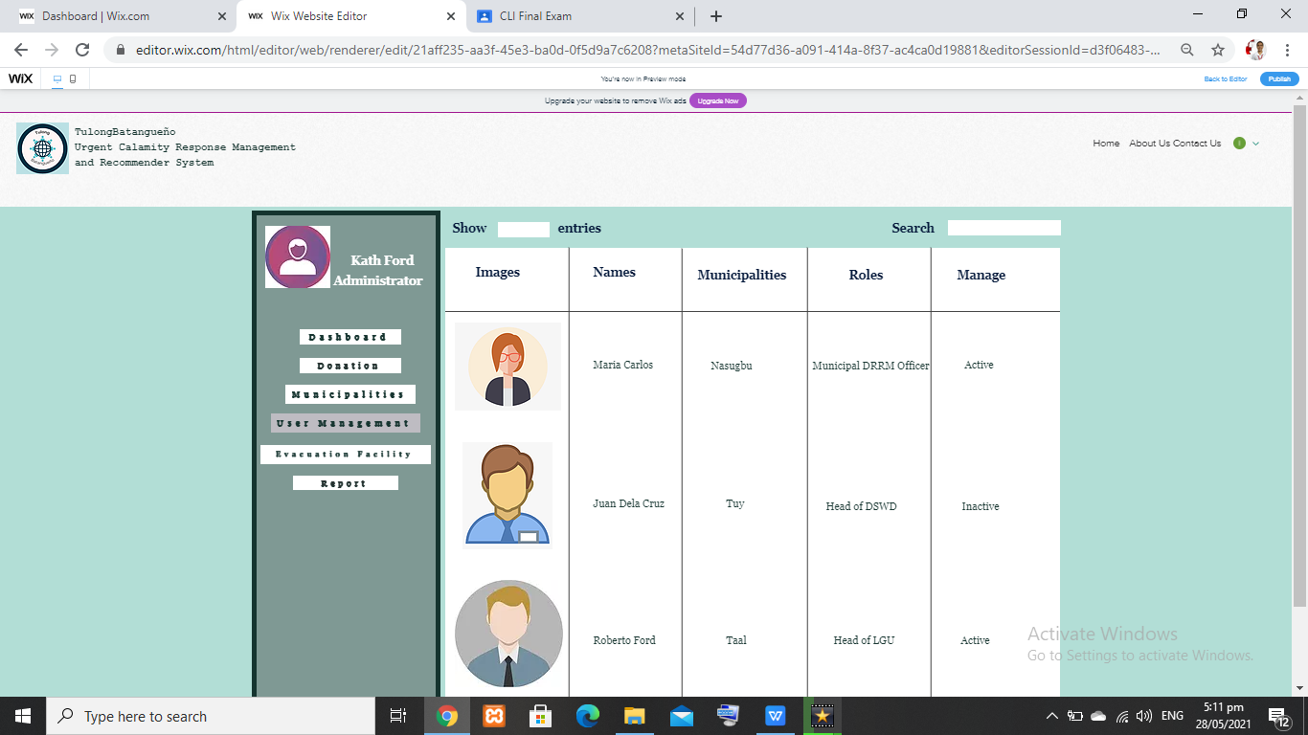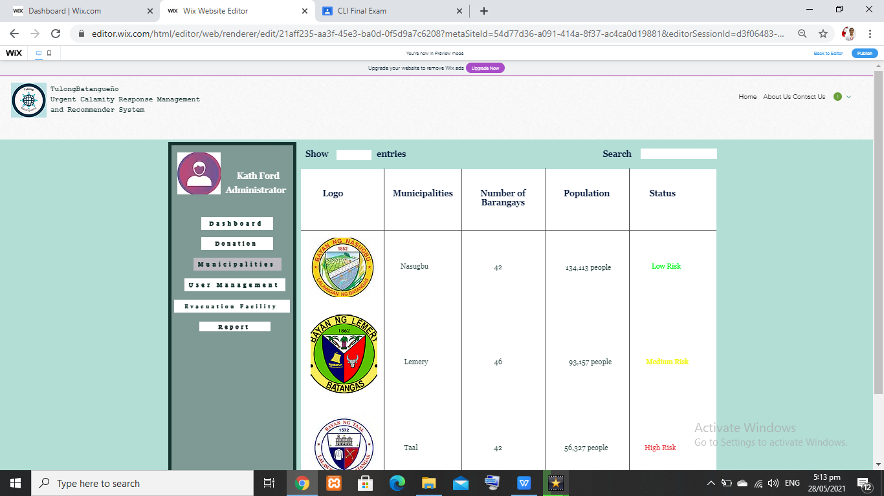

The User Management Tab consist of the user’s information as well as the admin activate their account during calamity.

(Screenshot zoom)

The Municipalities tab consist the list of Municipalities and their corresponding information

(Screenshot zoom)

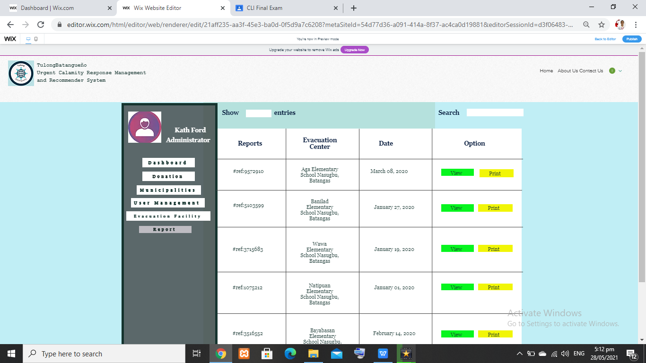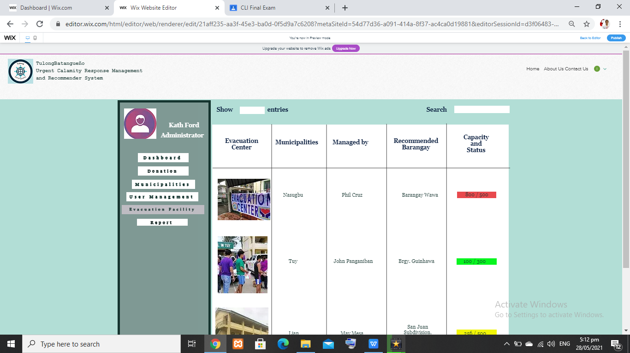

The Report tab has the list of all reports happen in times of calamity

(Screenshot zoom)

The Evacuation Facility tab has the list of all possible evacuation facility in the Batangas.

(Screenshot zoom)

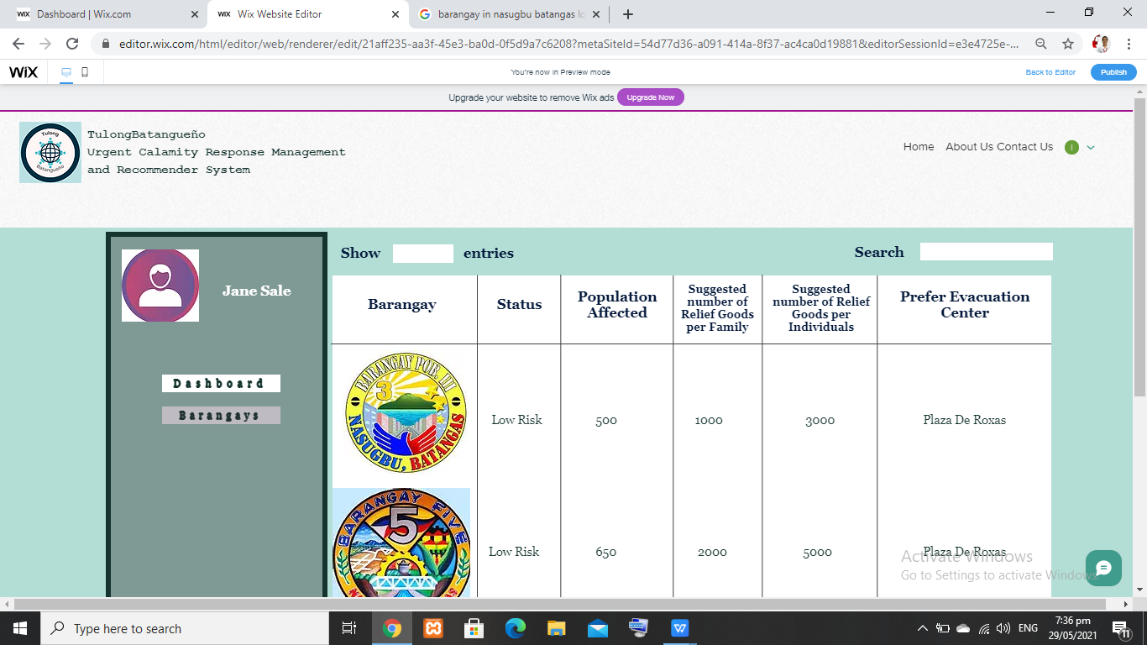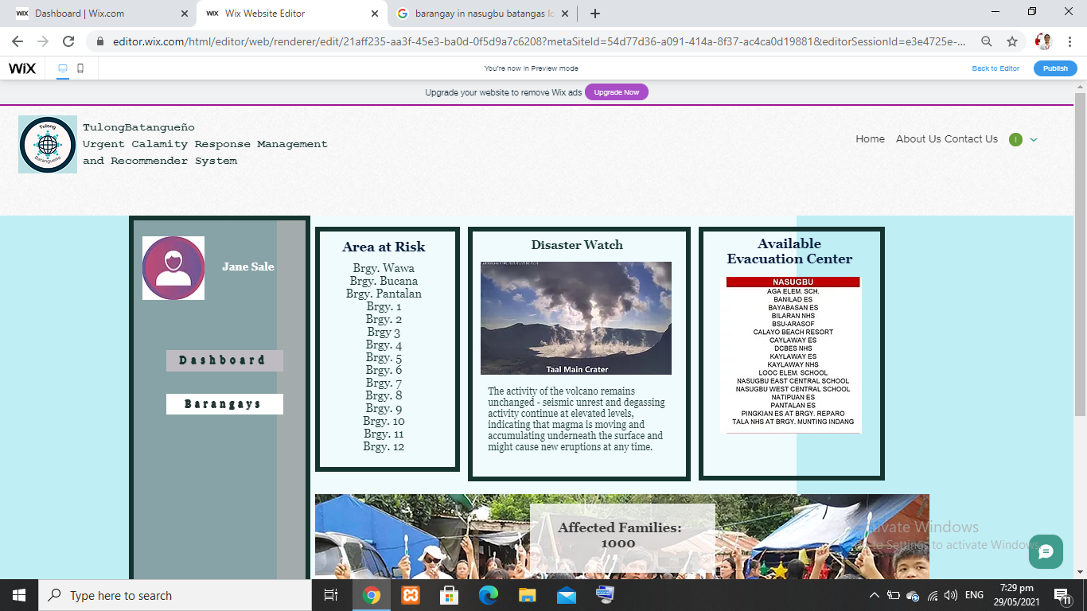

The LGU: Barangay tab consist of list of barangay within the municipalities and its information

This is the LGU: Dashboard interface. During the calamity, this interface will be activated via admin and the intended user will access the system. The dash board contains Area at risk pertaining to barangays , disaster watch and the available evacuation center

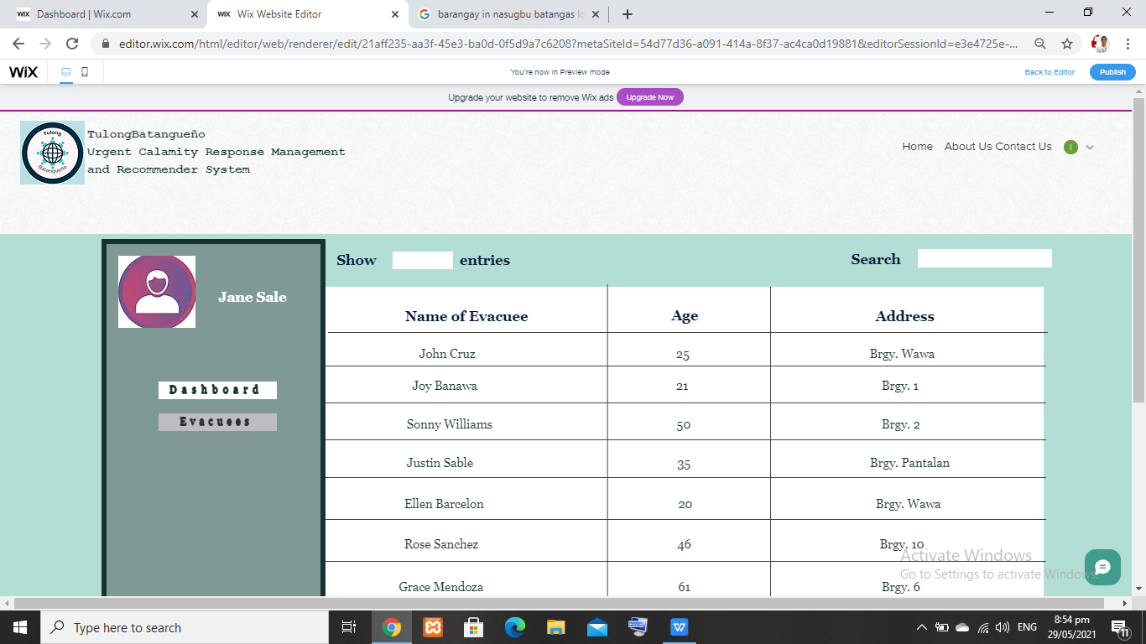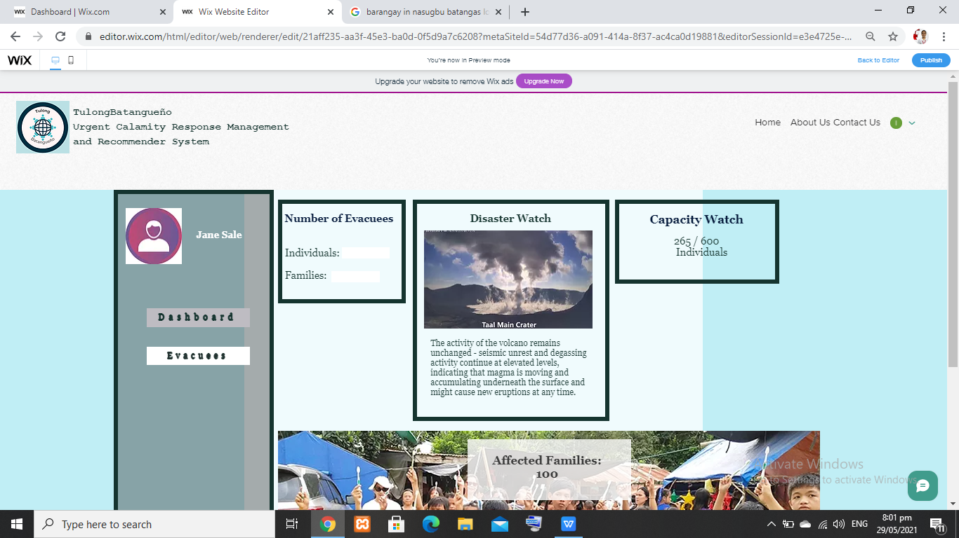

The Evacuation Facility: Evacuees tab consist of list of individual inside the evacuation center with their information.

The Evacuation Facility: Dashboard Interface provides the summary information inside a evacuation center that consist of Number of Evacuees which display both in individual and in family, disaster watch and also the capacity of the evacuation center

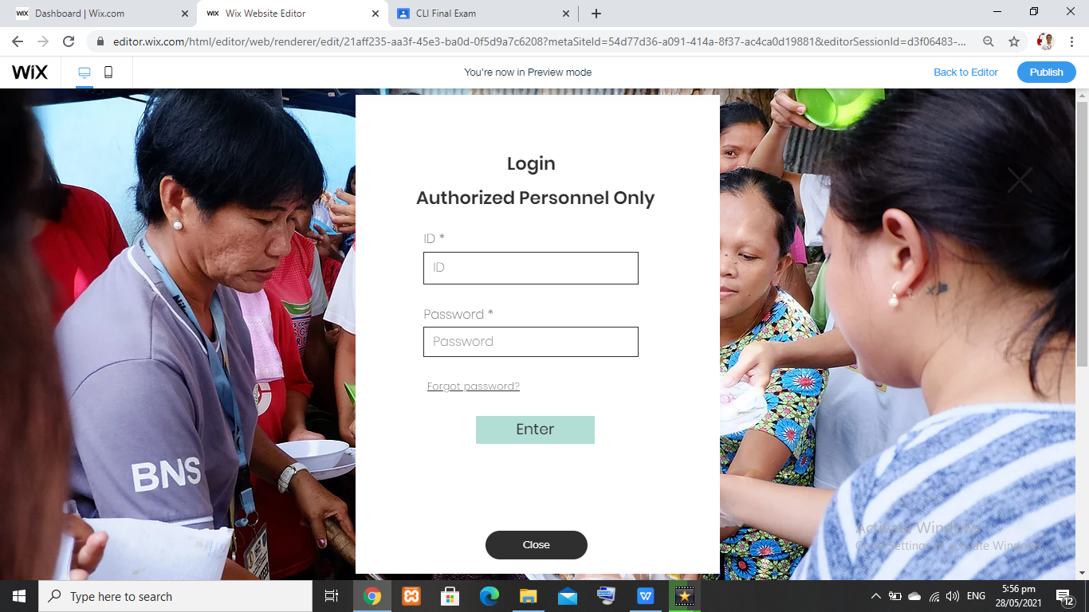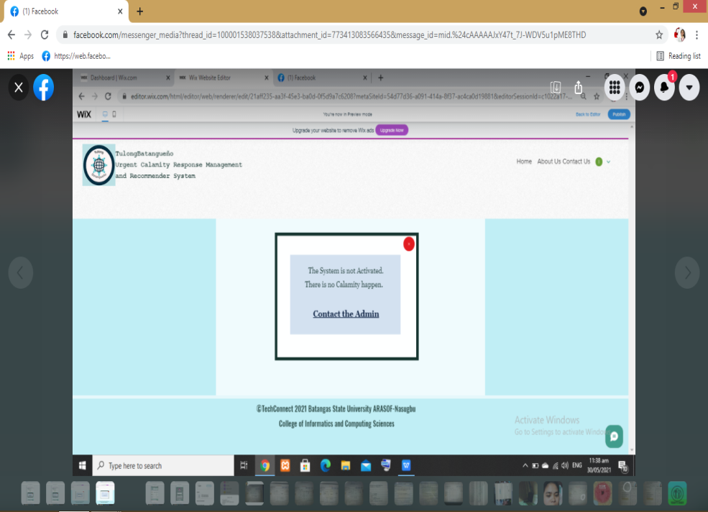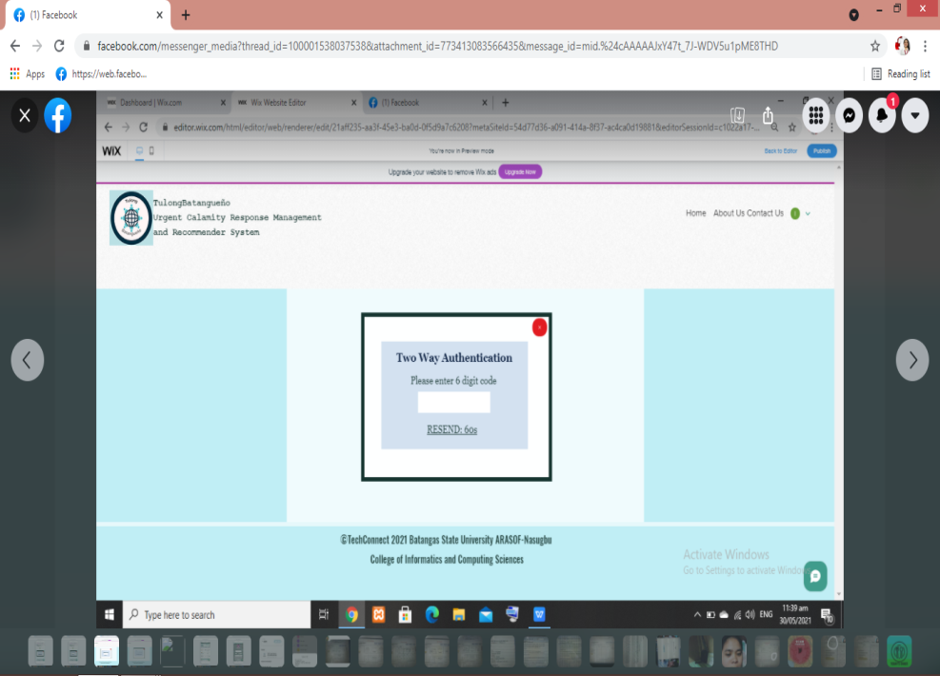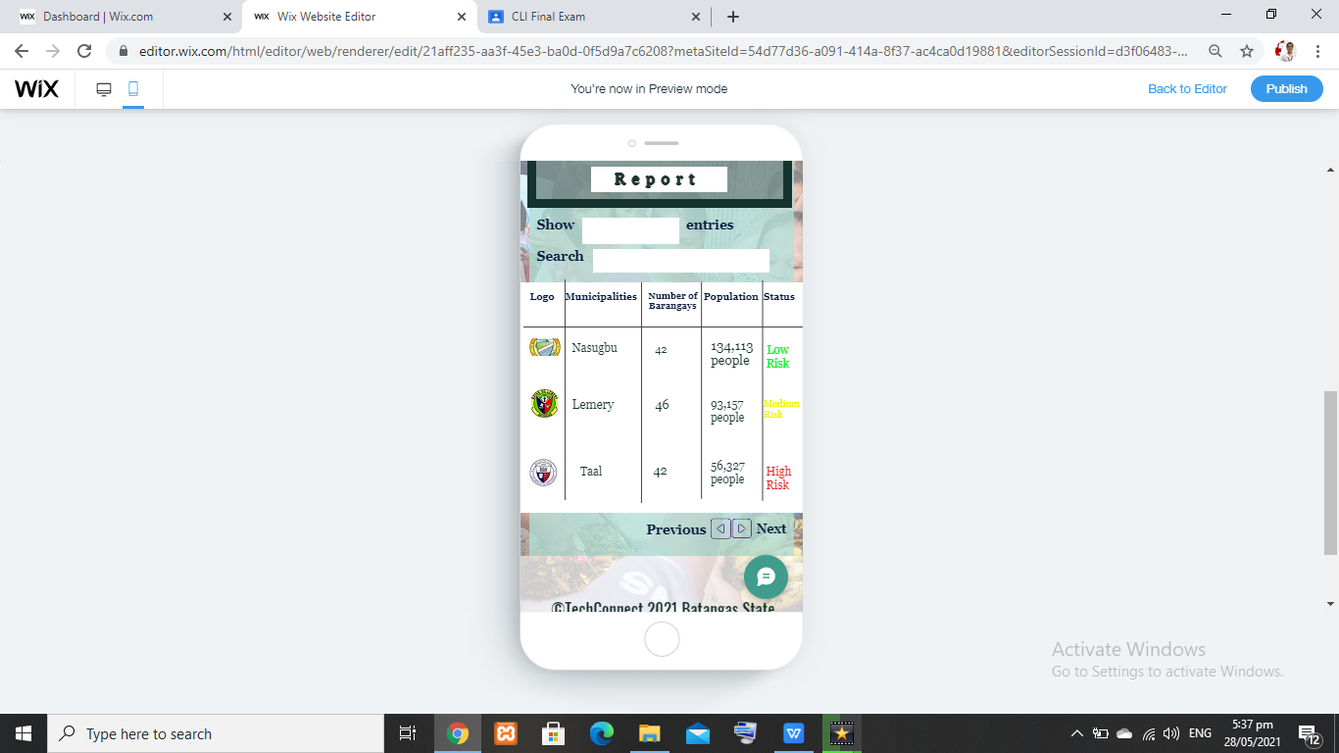

Two-way Authentication for security Purposes

The User login without a permission of admin

This is the Log in Form of the system

LGU: Barangays Interface